**Assigning Contract Acc Category**

Step 1: Follow the path

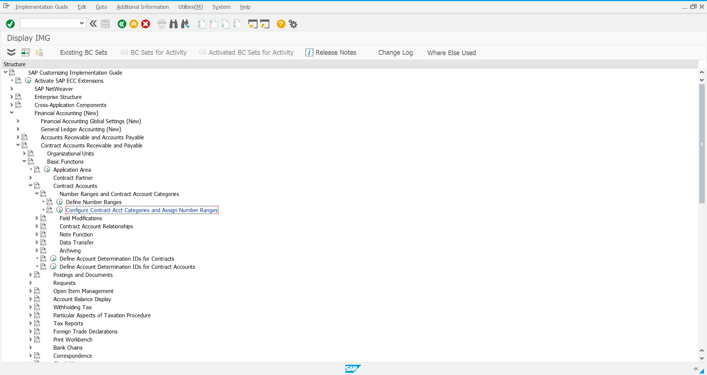

Step 2: Select new entries in the next screen

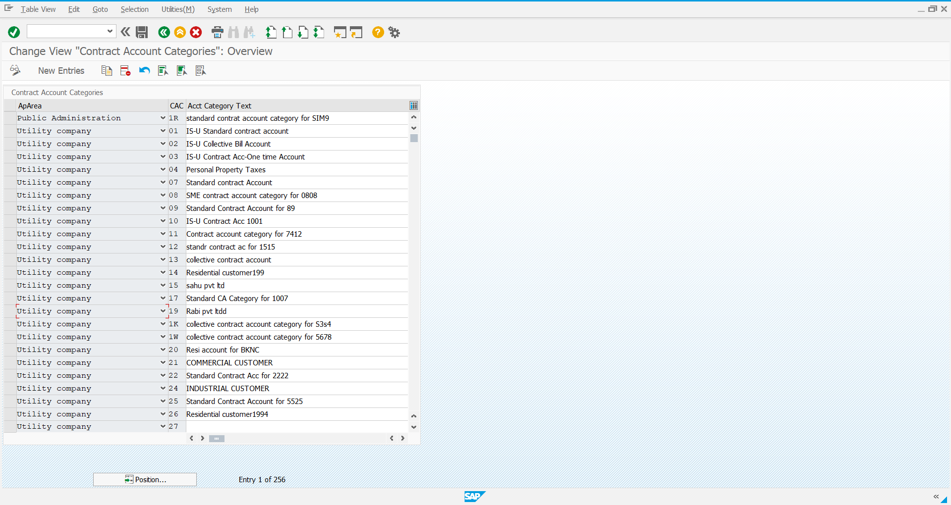

Step 3: Enter the required details

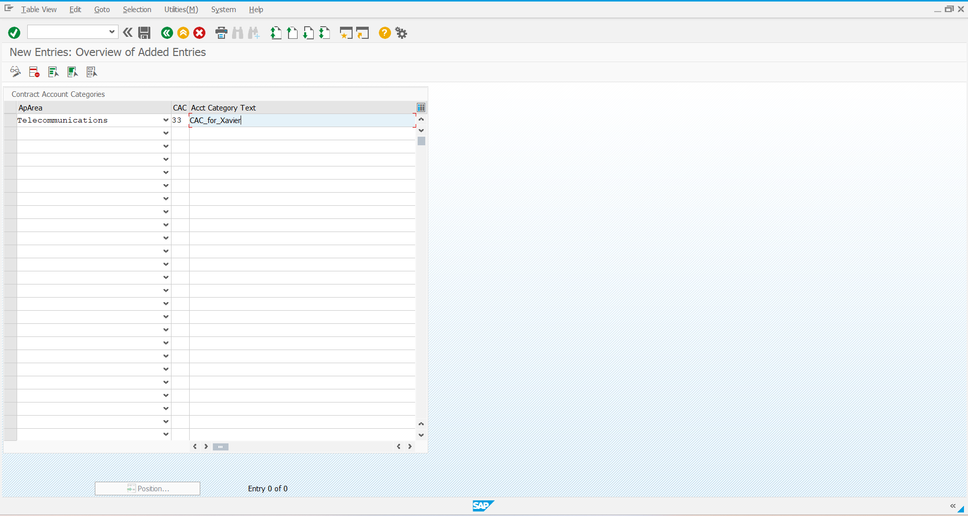

Step 4: Save it

